Julia Owen

Professor Cassens

MART 120

September 13, 2021

Mindset

Included below is a screenshot of my results for the mindset quiz:

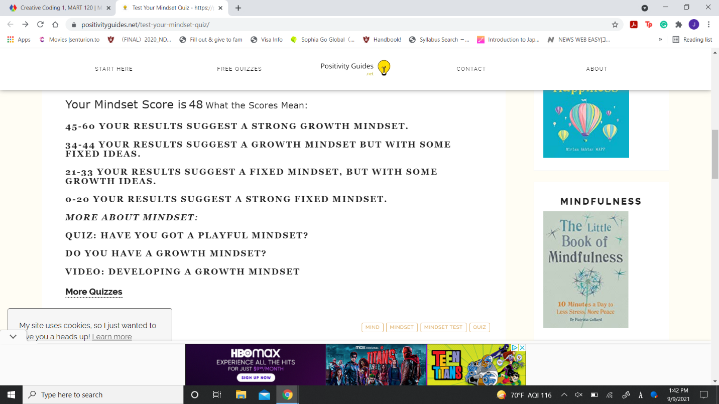

As shown in the screenshot, my mindset score is a 48, suggesting that I have a strong growth mindset. I’ve always been someone that has believed in a growth mindset, so I don’t have a new perspective on it. This also won’t affect my outlook looking forward because it’s something that I have already been thinking about since I can remember. As someone that has had to work really hard to learn things and become decent at them, I think that people can learn anything. For the class I tutor, when I was in it, I really thought that I was going to fail it in the beginning and possibly have to change my major. But I changed my outlook and knew that if I really tried and worked hard on it that I could pass the class. In the end, I created my own application that my professor suggested I copyright and sell. I went from thinking about changing my major to creating a successful application and being a tutor for the course. Today when I tutored, I had someone come in not knowing anything, and I really tried to show them the potential they had and that they could do code. By the end, they told me I was an amazing teacher and felt confident for the exam next week. Hearing that made me so happy, especially knowing that I was able to change their attitude from when they first came in. I hope that I can do that with many more students throughout this semester. I think a growth mindset is such an important thing needed to succeed in life, and helping others realize what they can do with a growth mindset is a great feeling.